STARAGILE KUBERNETES ASSIGNMENT

**Step 1: Go to Spring Initializr**

1. Open your web browser and navigate to [Spring Initializr](https://start.spring.io/).

**Step 2: Choose Configuration**

**Step 3: Select Dependencies**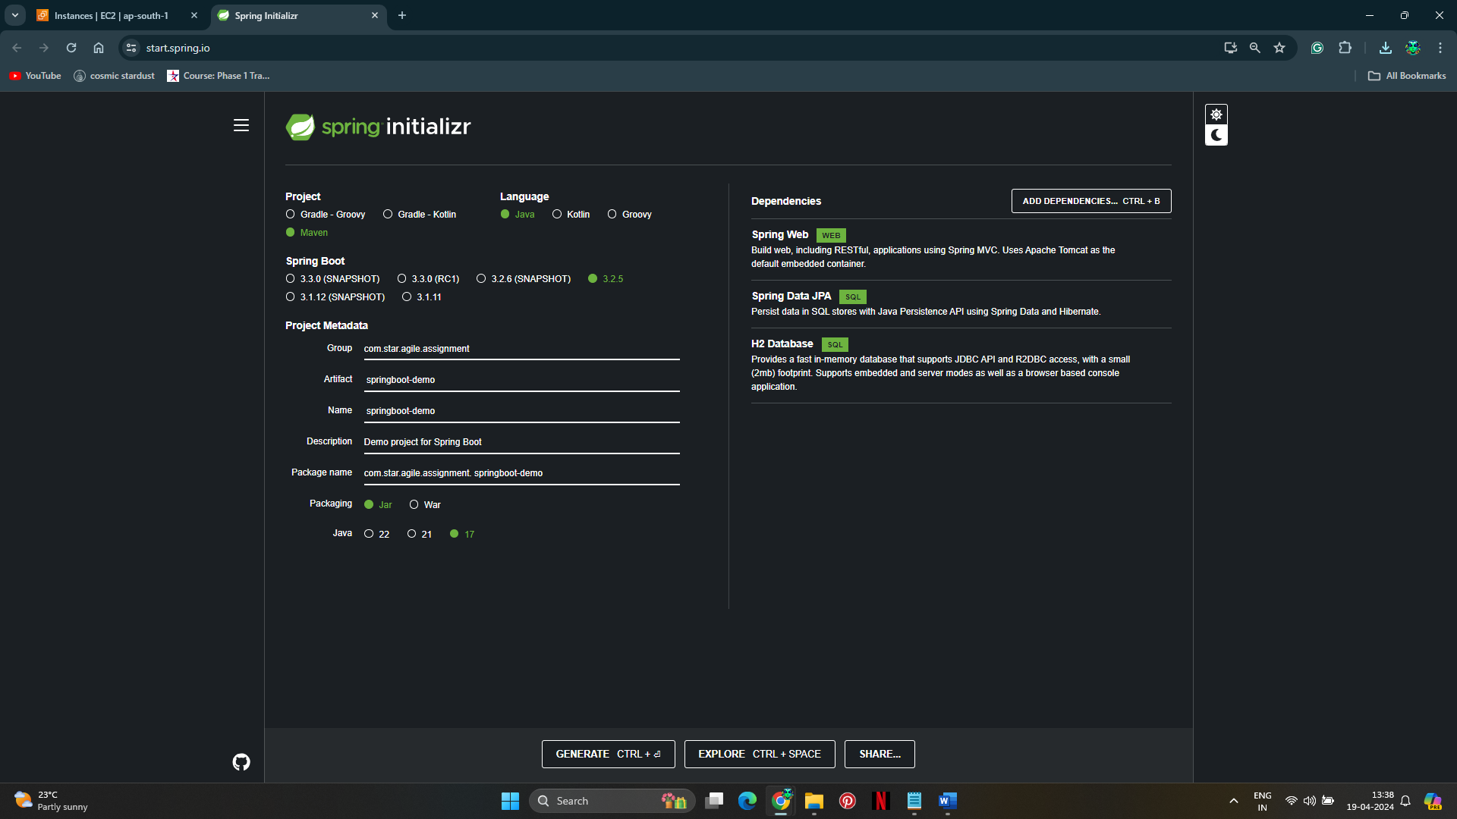

**Step 4: Verify Dependencies**

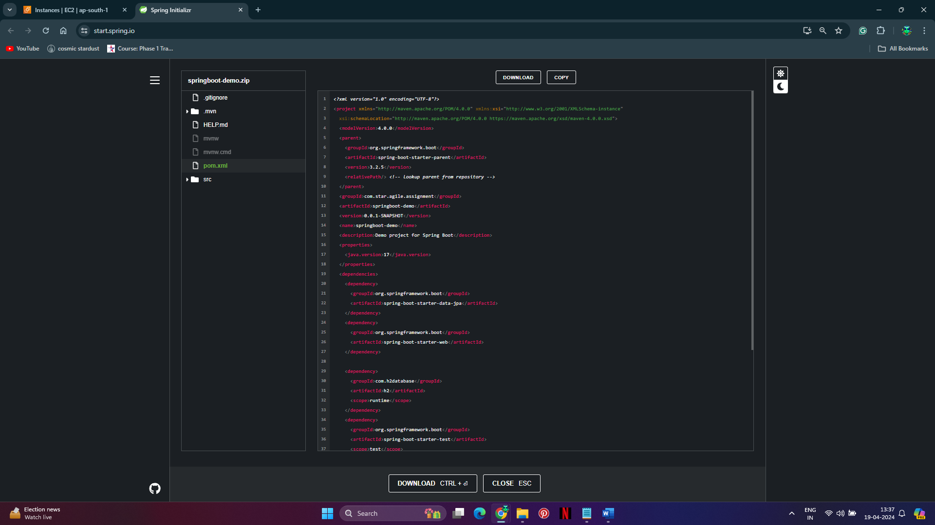

**Step 5: Download Project Template**

**Step 6: Import Project into Eclipse**

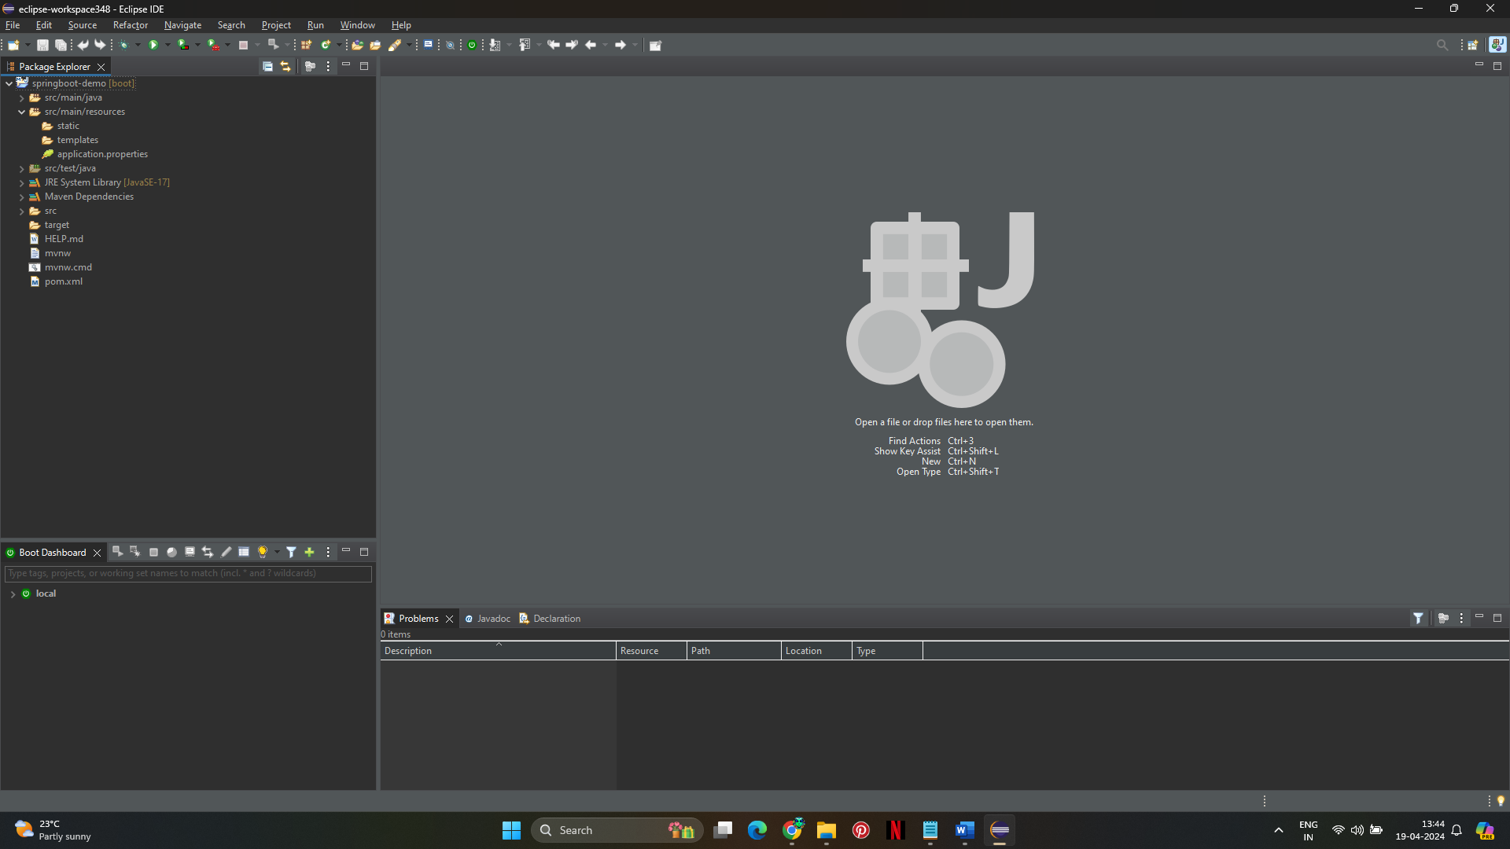

**Step 7: Add index.html**

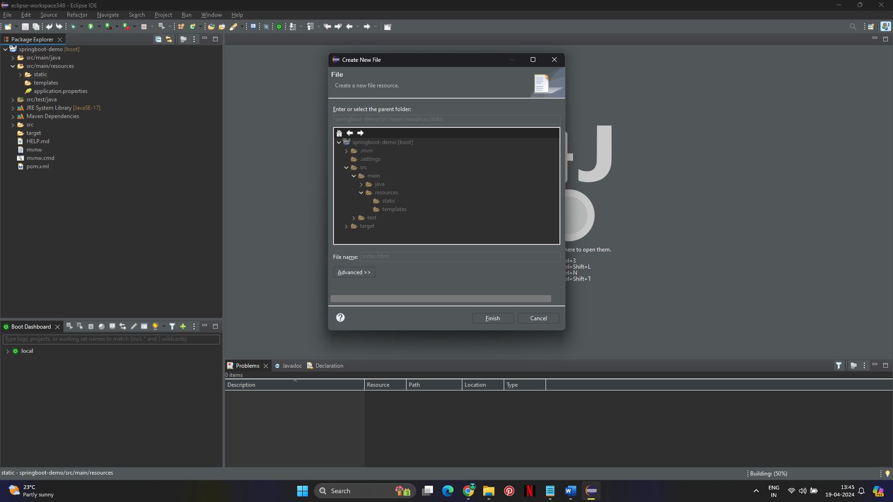

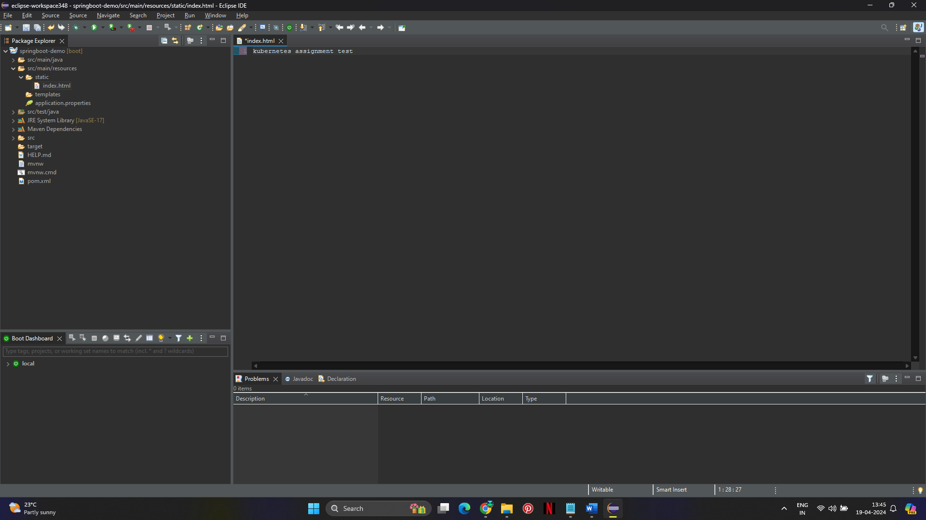

Test the Project

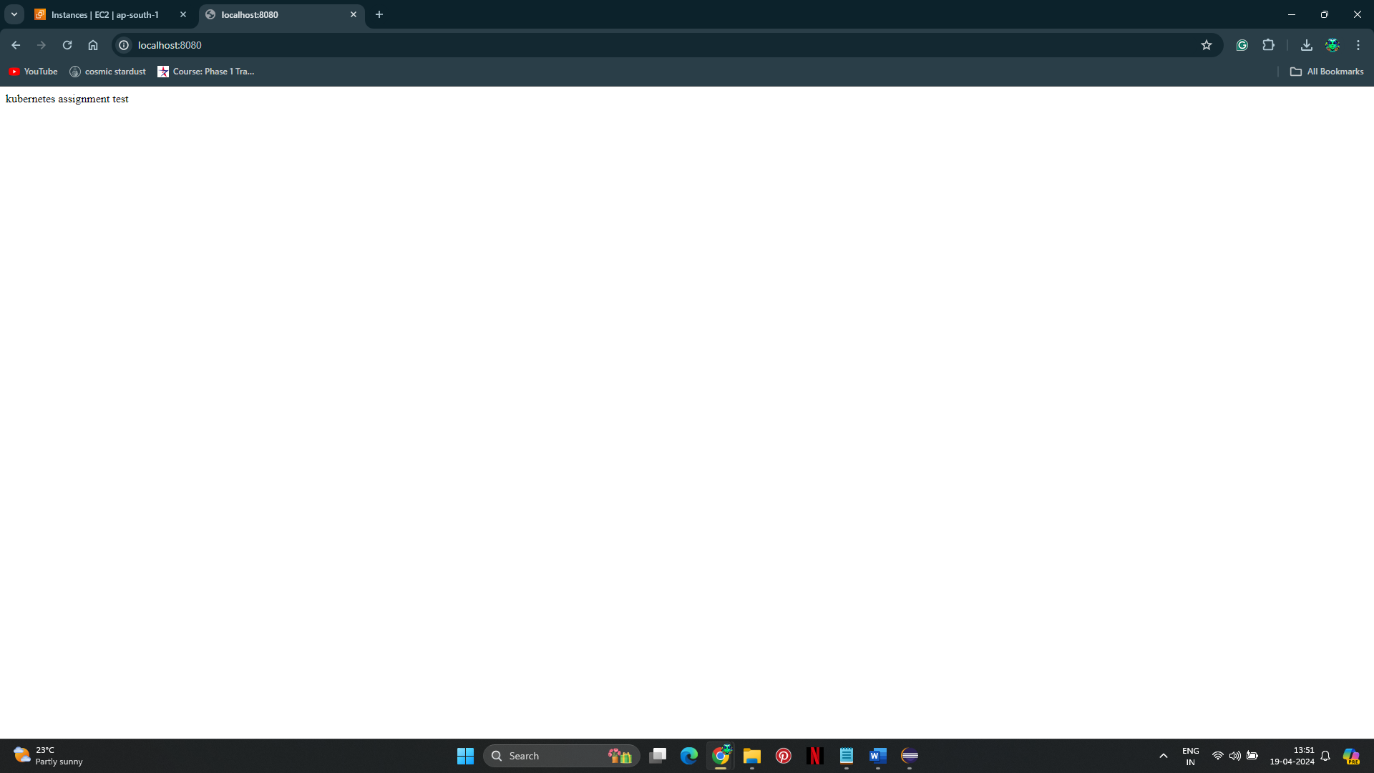

Build the project

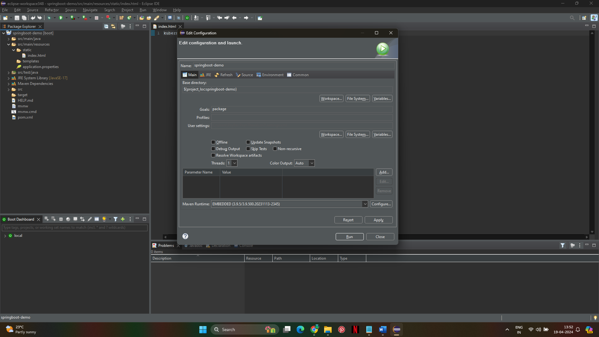

Upload to GIThub

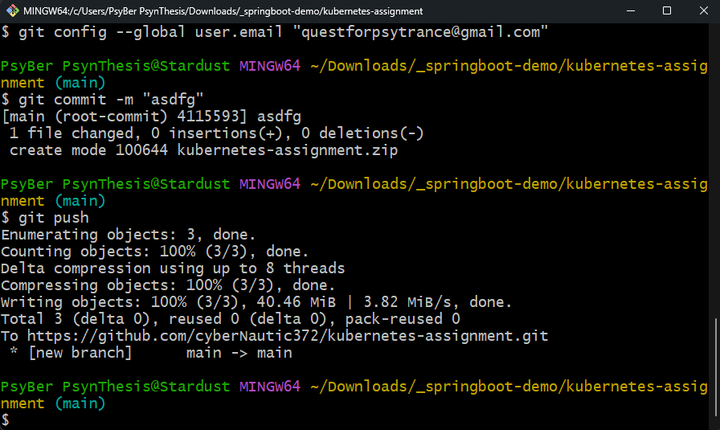

Clone the project

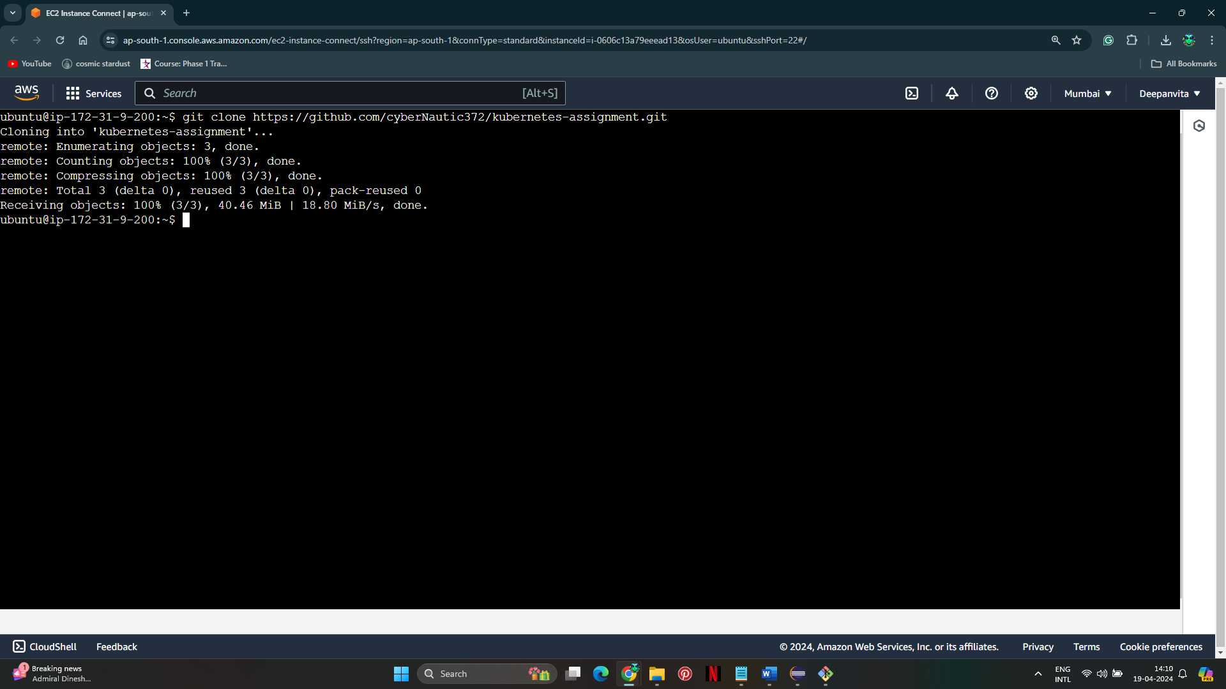

**Step 8: Write Dockerfile**

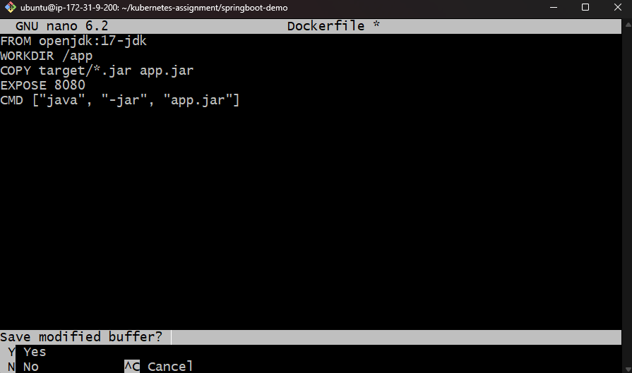

**Step 9: Build and Push Docker Image**

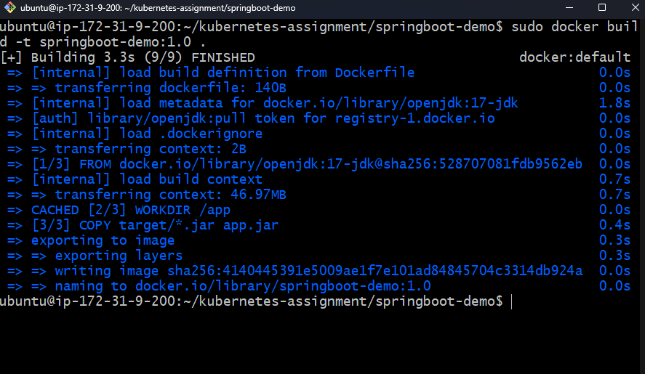

1. Tag the Docker image:

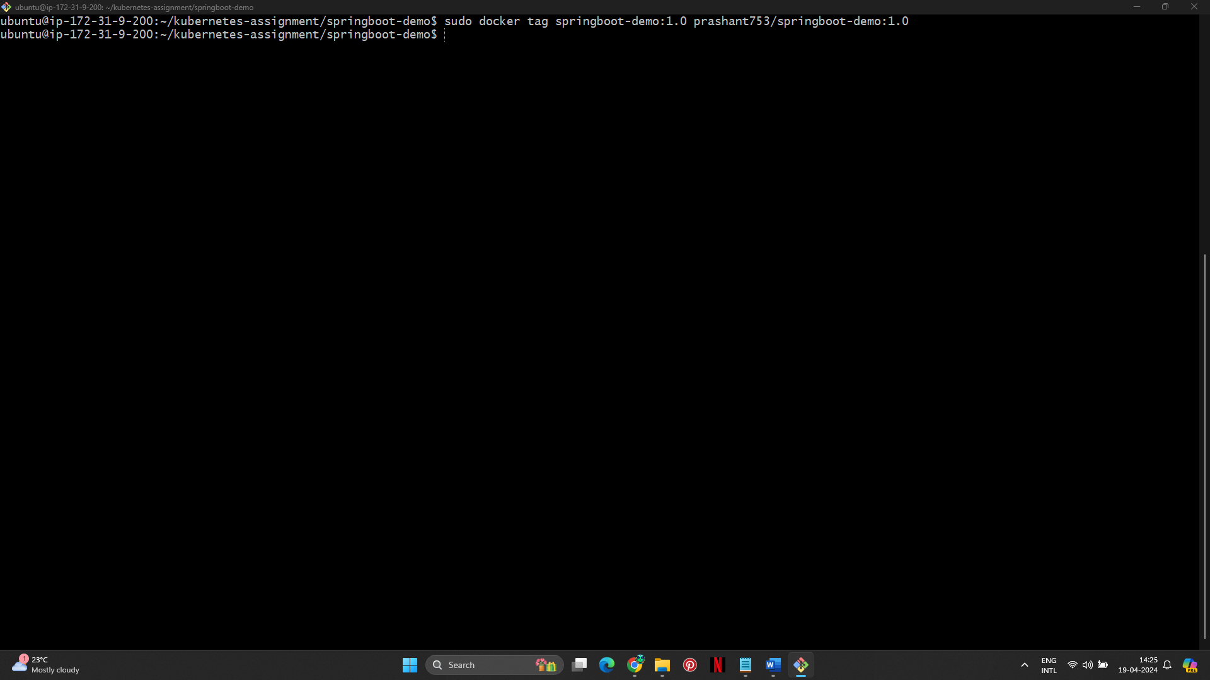

1. Push the Docker image to Docker Hub:

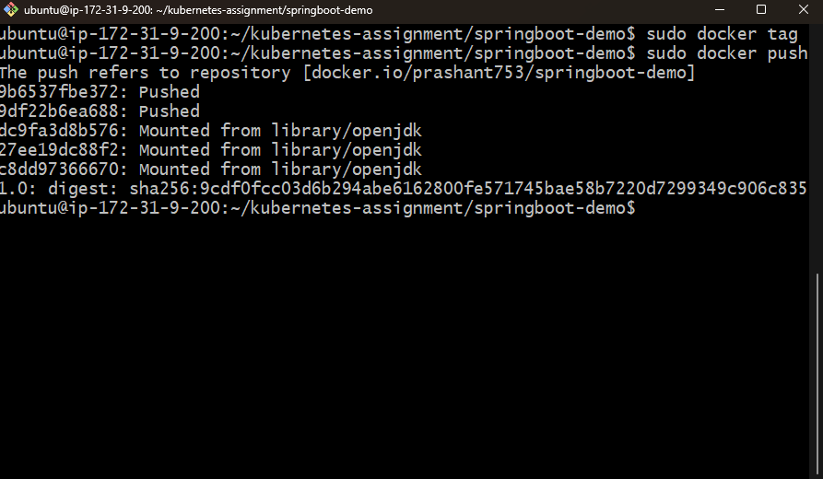

**Step 10: Setup Kubernetes Minikube Single Node Cluster**

1. **Install Minikube Dependencies**:

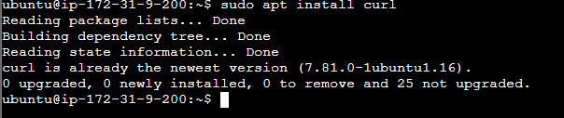

1. **Install VirtualBox**:

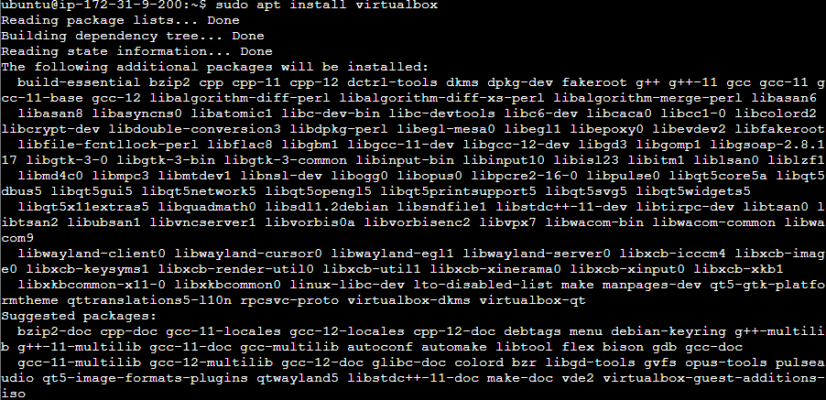

1. **Install kubectl**:

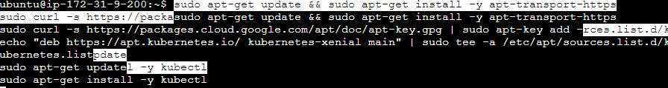

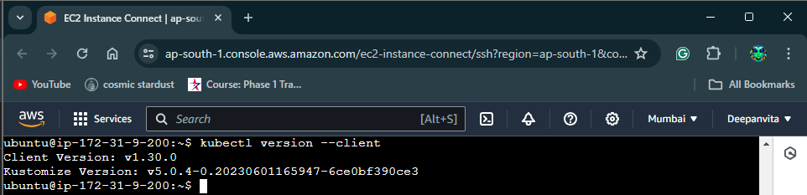

1. **Install Minikube**:

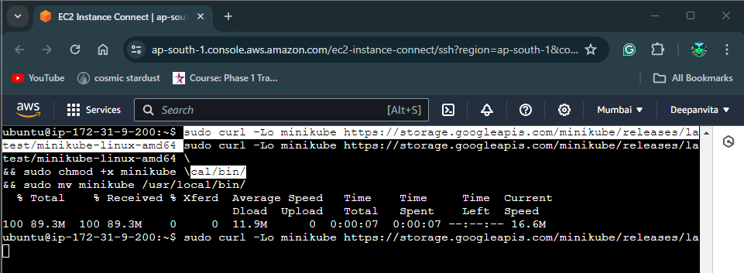

1. **Start Minikube**:

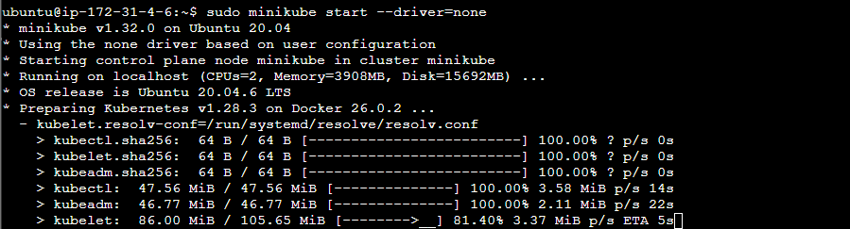

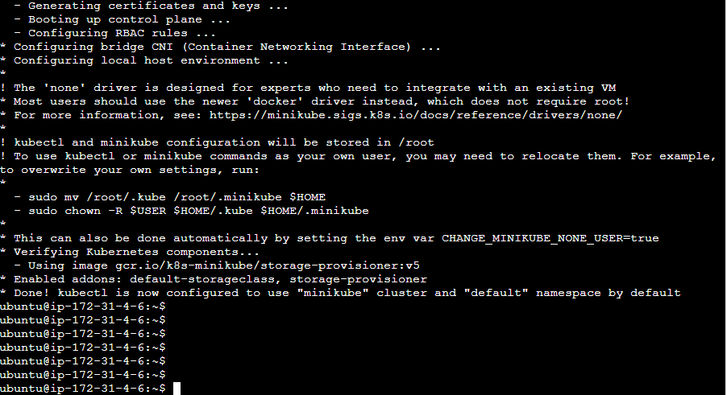

1. **Verify Minikube**: Check if Minikube is running and the cluster is up:

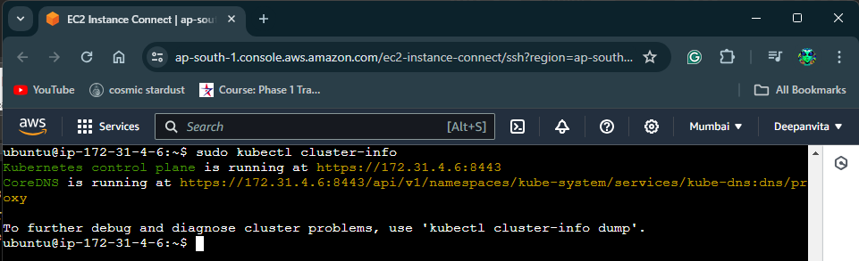

**Step 11: Write a Deployment to Deploy the Application as a Pod Using kubectl**

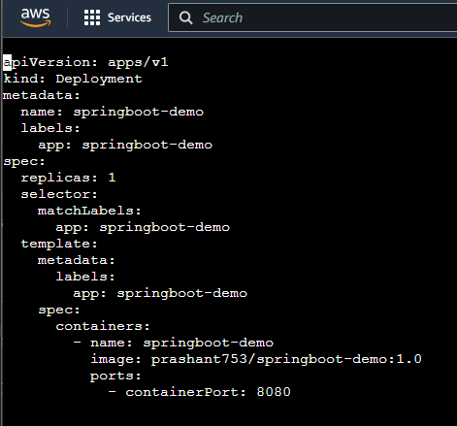

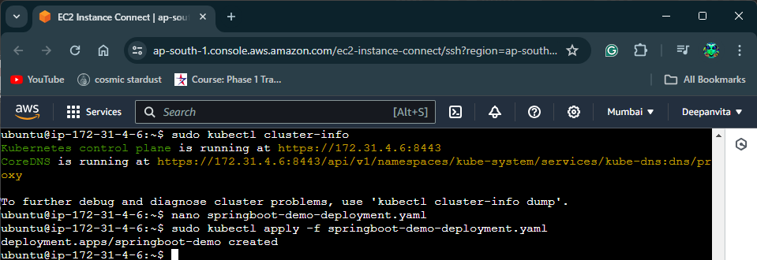

**Apply the Deployment**

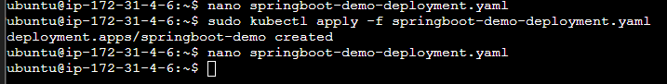

**Verify Deployment**:

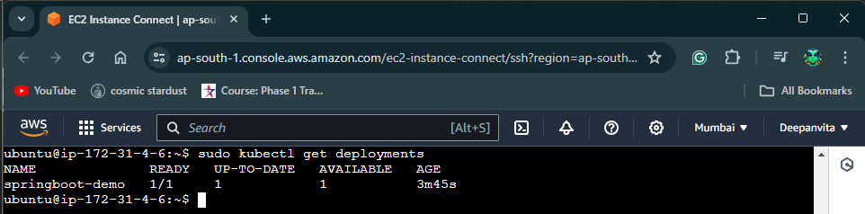

**Check Pods**:

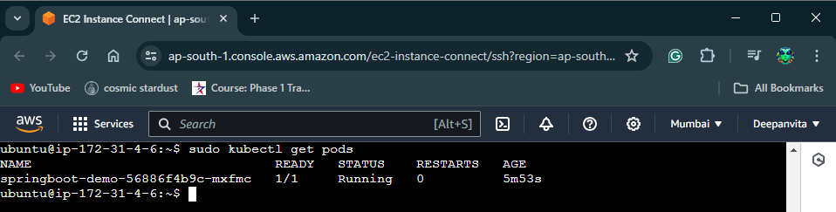

**Step 12: Create the NodePort Service to Expose the Deployed Container to the Outside World**

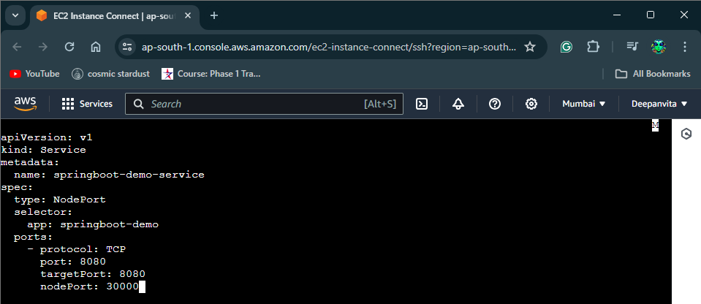

**Apply the Service**:

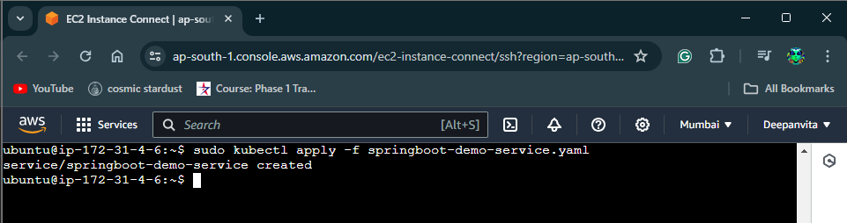

**Verify Service**

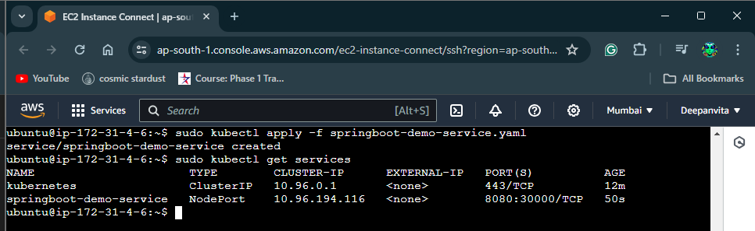

**Step 13: Verify the Application Over Browser**

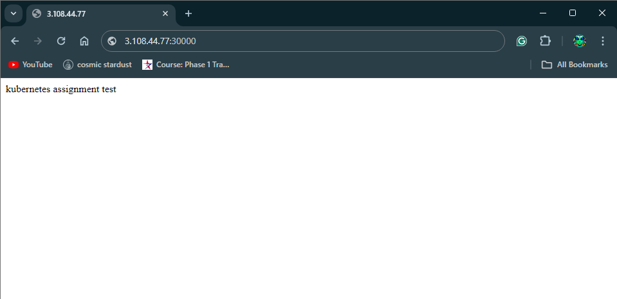

**Step 14: Add Hello World.html to the Spring Boot Application**

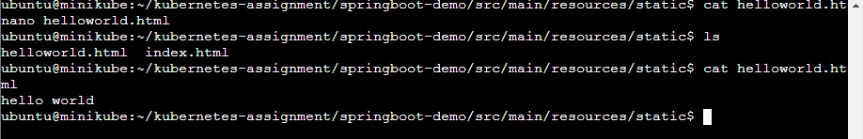

**Step 15: Build the Docker Image and Give the Tag as 2.0**

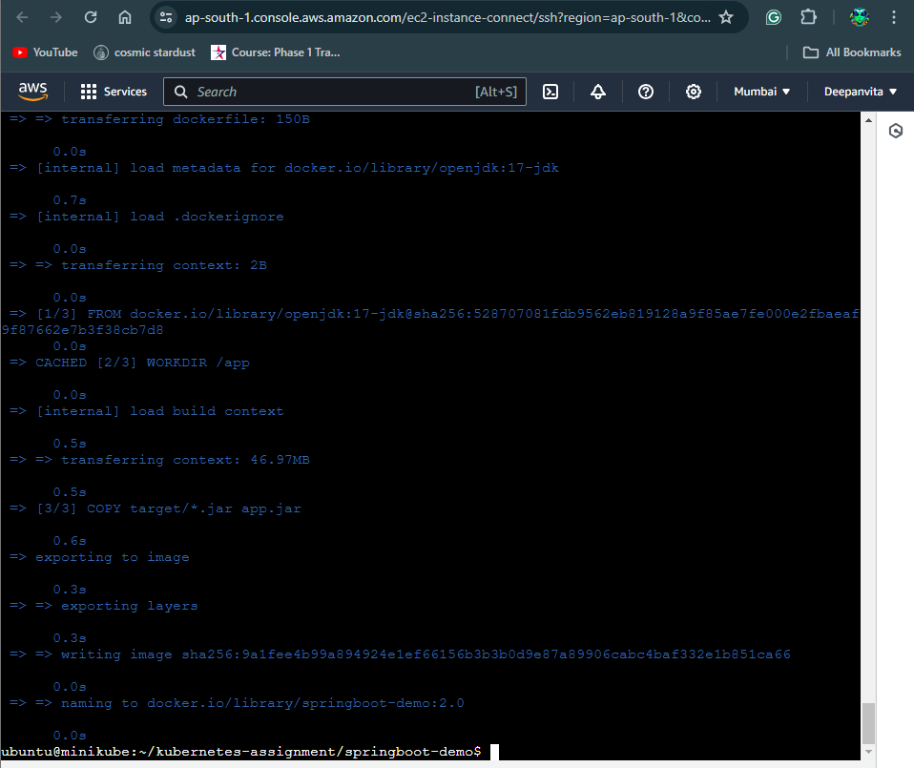

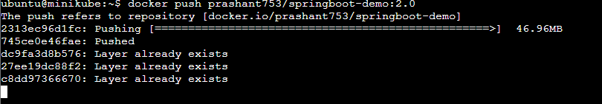

**Step 16: Roll Out the Deployment of the 2.0 Version**

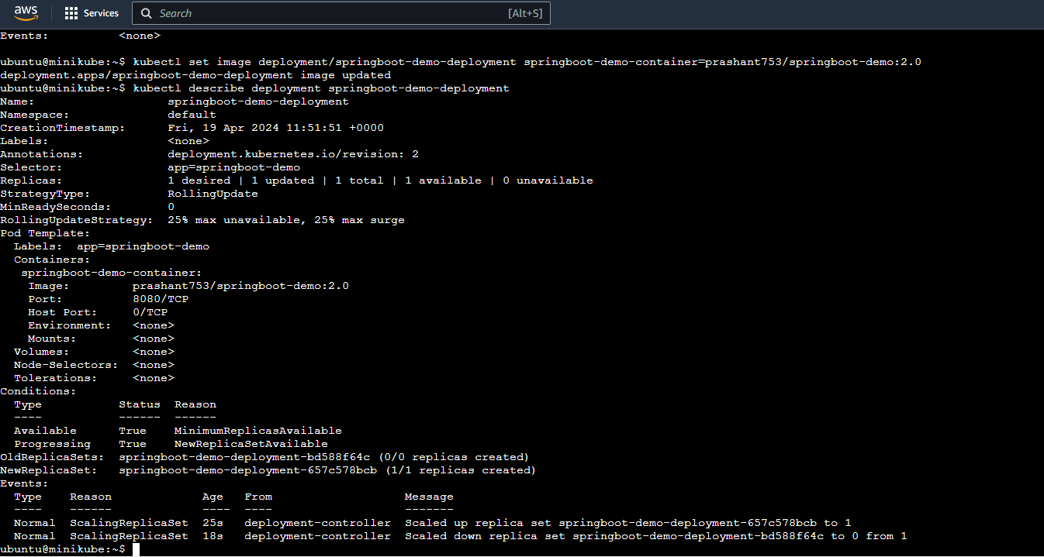

**Step 17: Verify the App that New Version has Been Deployed**

1. Refresh your browser and check if the new version is deployed successfully.

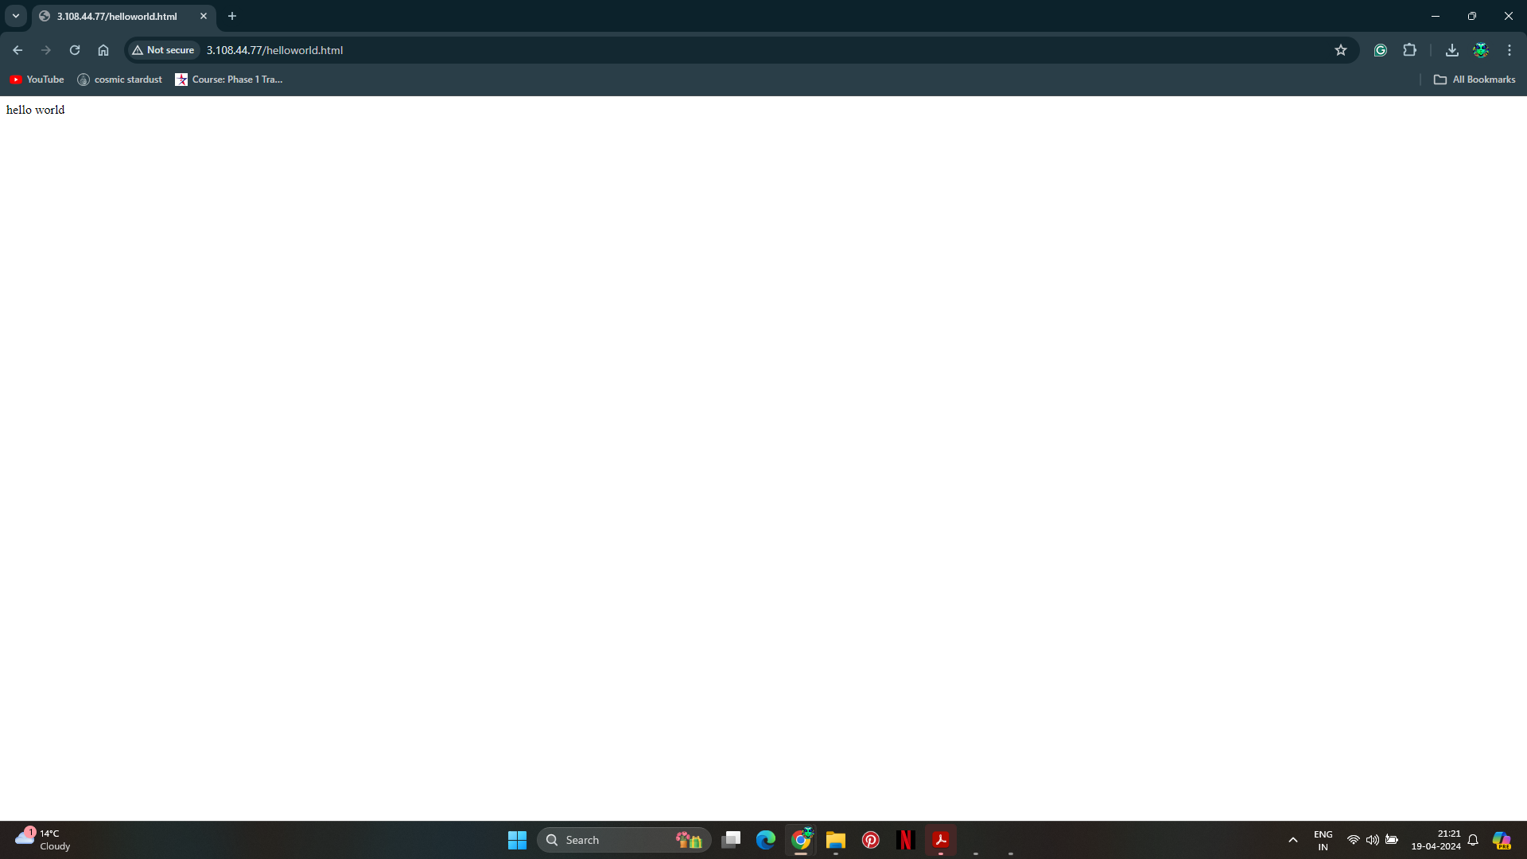

**Step 18: Rollback the Deployment to the Old Version**

1. Rollback the deployment to the previous version:



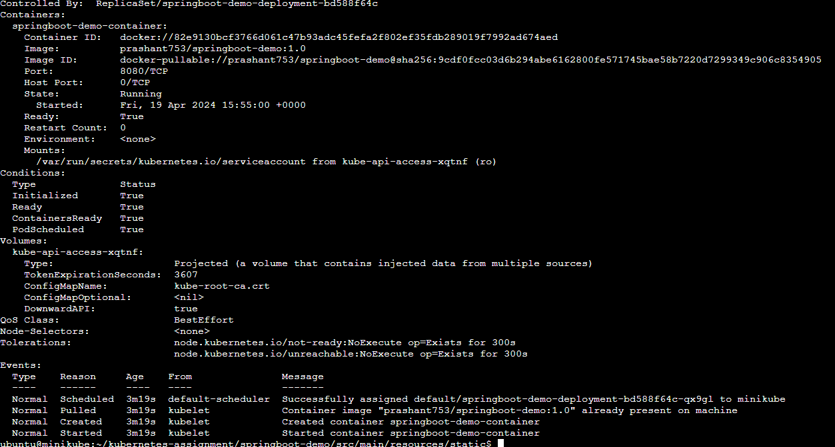

**Step 19: Verify the Version and Try to Access helloworld.html**

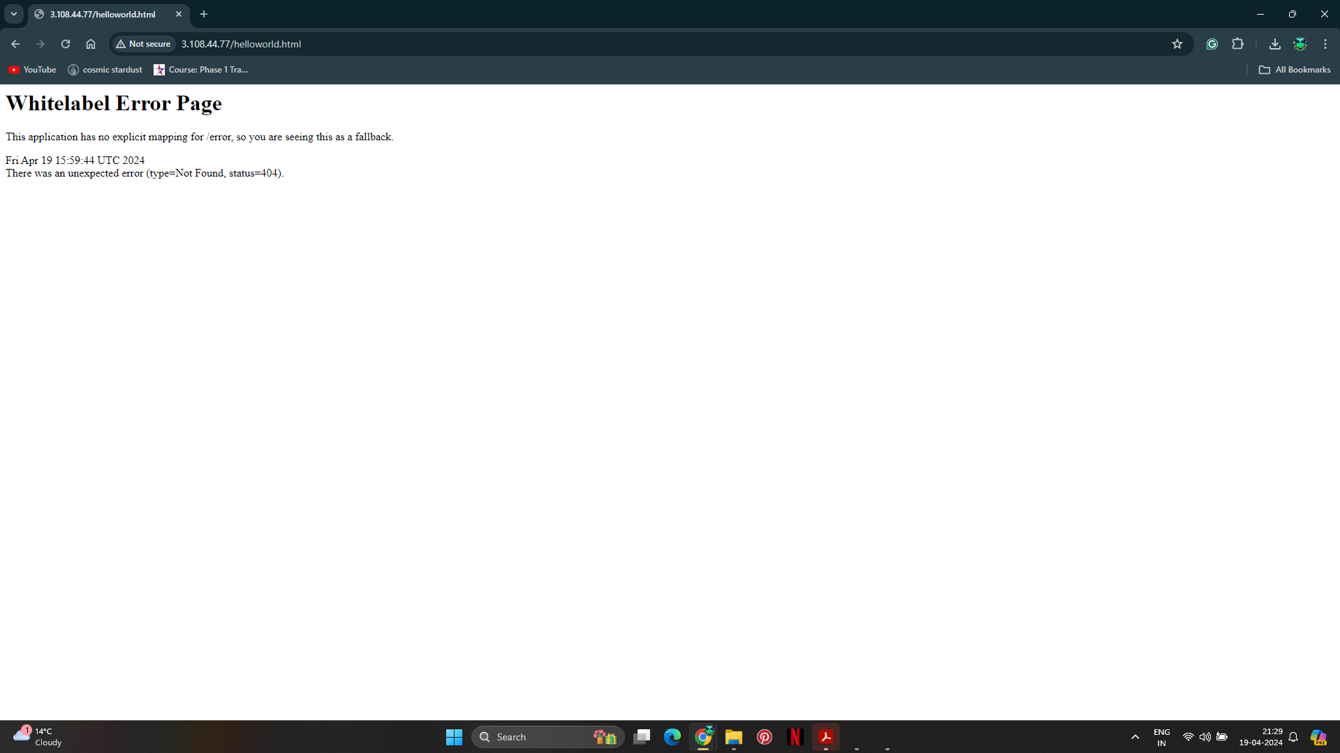

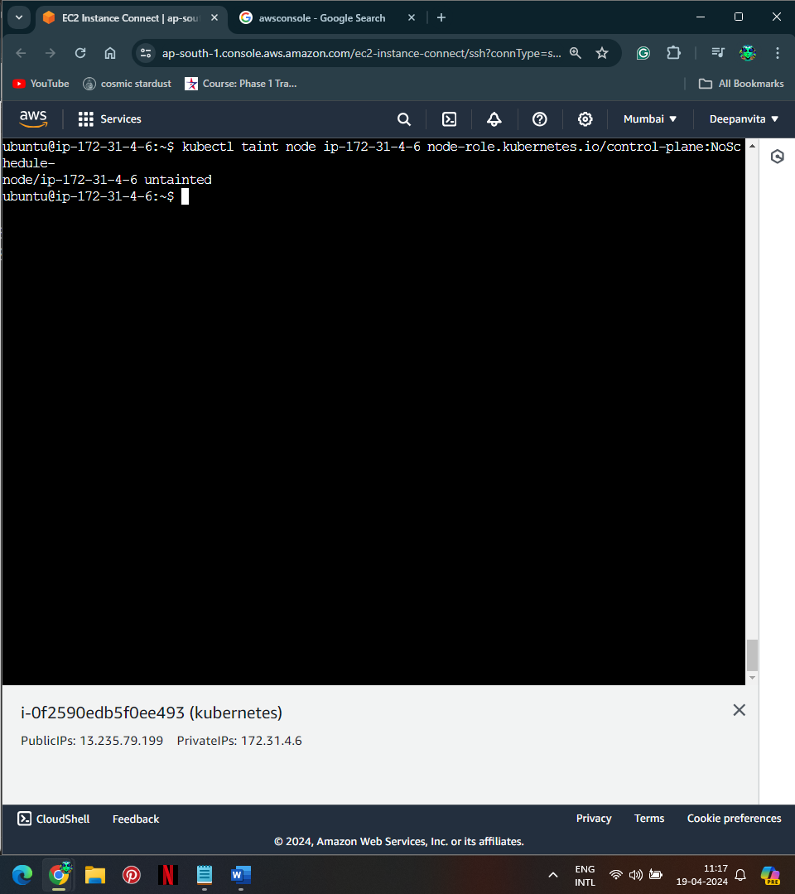

Describe pod